Automated Review System


Dataset Source: Kaggle
Dataset name: Bumble-dating-app-google-play-store-review

Rows, Columns: 178573, 11

Features: ['reviewid', 'username', 'userimage', 'content', 'score',
'Thumbsupcount', 'reviewcreatedversion', 'at', 'replycontent',
'Repliedat', 'appversion']

data.info()

S.no | Column name | Non-null count | Data type
1 | Reviewid | 178,573 | Str
2 | Username | 178,573 | Str
3 | Userimage | 178,573 | Str
4 | Content | 178,555 | Str
5 | Score | 178,573 | Int64
6 | Thumbsupcount | 178,573 | Int64
7 | Reviewcreatedversion | 146,430 | Str
8 | At | 178,573 | Str
9 | Replycontent | 122,830 | Str
10 | Repliedat | 122,830 | Str
11 | Appversion | 146,430 | Str


Libraries used in the project

Library | Definition / Purpose
Pandas (pd) | Used for data manipulation, cleaning, and handling structured datasets in tabular form.
Regular Expressions (re) | Used for text preprocessing tasks such as pattern matching, cleaning, and removing unwanted characters.
spaCy (spacy) | Used for Natural Language Processing (NLP) tasks including tokenization, lemmatization, and text preprocessing.
Matplotlib (matplotlib) | Used for creating data visualizations such as plots, charts, and graphs.
NumPy (np) | Used for numerical computations and efficient handling of arrays and mathematical operations. (Here helped in customize the x-axis tick intervals.)
Seaborn (sns) | Used for generating statistical data visualizations with enhanced aesthetics built on top of Matplotlib. (Here, violin plot)


Data Preprocessing

- Handling Missing Values

data.isnull().sum()

Column name | Missing values
Reviewid | 0
Username | 0
Userimage | 0
Content | 18
Score | 0
Thumbsupcount | 0
Reviewcreatedversion | 32,143
At | 0
Replycontent | 55,743
Repliedat | 55,743
Appversion | 32,143

The rows with missing values in the “Content” feature, as well as duplicate and conflicting records, were removed.

data1 = data.dropna(subset = ['content'])

- Remove Duplicates and Conflicts

data1 = data1.drop_duplicates(subset="content", keep='first')
data1 = data1.reset_index(drop=True)

- Drop Unnecessary Columns/Rows
Following the preprocessing stage, only the relevant features were retained for analysis: reviewId (identifier), content (review text), score (rating), thumbsUpCount (popularity), and at (timestamp).

data1 = data1.drop(['userName','userImage','reviewCreatedVersion',
'replyContent','repliedAt','appVersion'], axis = 1)

- Clean the Review Text

- Converted all text to lowercase to ensure consistency and avoid treating words with different cases as separate terms.
- Removed URLs (e.g., website links starting with http, https, or www) from the review text.
- Removed HTML tags to eliminate any markup elements present in the reviews.
- Removed punctuation and special characters, retaining only letters, numbers, and spaces.
- Removed extra whitespace by replacing multiple spaces with a single space and trimming leading/trailing spaces.

def clean_text(text):

text = text.lower()

# Remove URLs
text = re.sub(r'https?://\S+|www\.\S+', '', text)

# Remove HTML tags
text = re.sub(r'<.*?>', '', text)

# Remove punctuation and special characters
text = re.sub(r'[^a-zA-Z0-9\s]', '', text)
text = re.sub(r'\s+',' ', text).strip() #removed extra space

return text

data1['content'] = data1['content'].apply(clean_text)

Before Cleaning Review
- Finally, an app where women have to start the conversation. Love the concept
- Nice and smooth.
After Cleaning Review
- finally an app where women have to start the conversation love the concept
- nice and smooth

- Lemmatization

Lemmatization is a text preprocessing technique in Natural Language Processing (NLP) that reduces words to their base or dictionary form (lemma) while considering the word's meaning and grammatical context.

nlp = spacy.load("en_core_web_sm", disable=["parser", "ner"])
data1['content'] = [
" ".join(token.lemma_ for token in doc)
for doc in nlp.pipe(data1['content'], batch_size=1000)]

- Remove stopwords
When using spaCy (en_core_web_sm), common stopwords that can be removed include: a, an, the, is, are, am, was, were, and, or, but, if, because, as, in, on, at, by, for, from, to, of, with, about, against, between, into, this, that, these, those, he, she, it, they, we, you, have, has, had, do, does, did, will, would, can, could, should, may, might

def remove_stopwords(text):
doc = nlp(text)
return " ".join(
token.text
for token in doc
if not token.is_stop )

Before lemmatization and stopword removal
- I supposedly have 3 likes and have been swiping for ages (I won't pay for premium, those prices are ridiculous).
After lemmatization and stopword removal
- supposedly like swipe age pay premium price ridiculous

- Remove Very Short Reviews

Filter out reviews with extremely low text length. Min-3 words

data1['word_count'] = data1['content'].str.split().str.len()
data1 = data1[
(data1['word_count'] >= 3) &
(data1['word_count'] <= 100)]


Feature Engineering

Create additional features such as: Word count and Character count

data1['char_count'] = data1['content'].apply(len)
data1['word_count'] = data1['content'].apply(lambda x: len(x.split()))

- Character Count (char_count): The total number of characters present in a review, including letters, numbers, spaces, and punctuation marks.
- Word Count (word_count): The total number of words present in a review, calculated by splitting the text based on spaces.

Final Class Distribution

⭐ - 72890
⭐ ⭐ - 14041
⭐ ⭐ ⭐ -10938
⭐ ⭐ ⭐⭐ -12074
⭐ ⭐ ⭐⭐⭐ -20556


Data Visualization

Bar chart - Distribution of Ratings

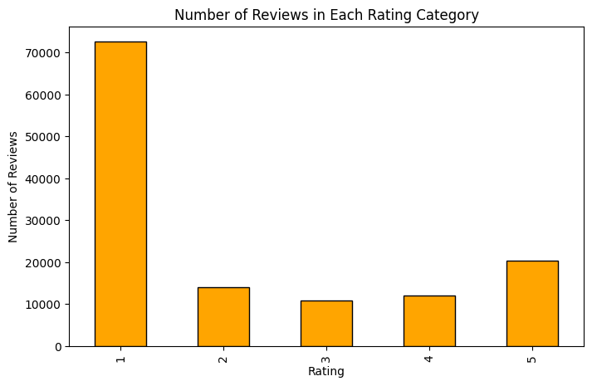

- The dataset is highly imbalanced, with Rating 1 dominating all other categories.
- More than 70,000 reviews belong to Rating 1, while the remaining ratings have significantly fewer reviews, indicating a strong skew toward this category.
- Positive ratings are less frequent than negative ratings.

Pie chart – Distribution of Ratings

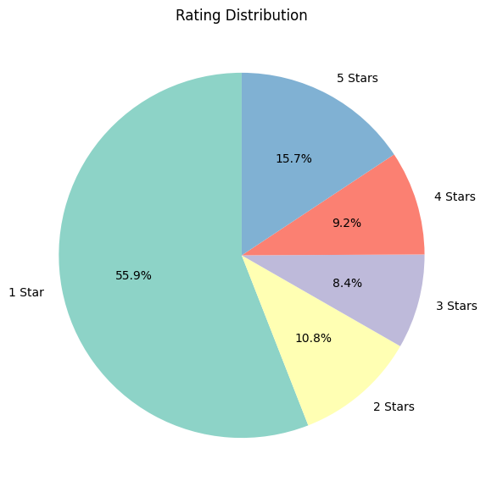

Histogram – Review Length Distribution

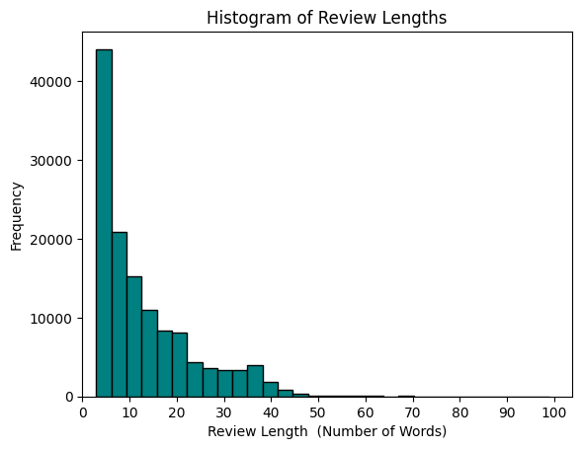

- Most reviews are short in length
- The highest frequency is concentrated between approximately 3 and 10 words, indicating that users generally provide brief reviews rather than detailed feedback
- The distribution is positively (right) skewed. As the review length increases, the frequency decreases sharply.

Boxplot – Review Length per ratings

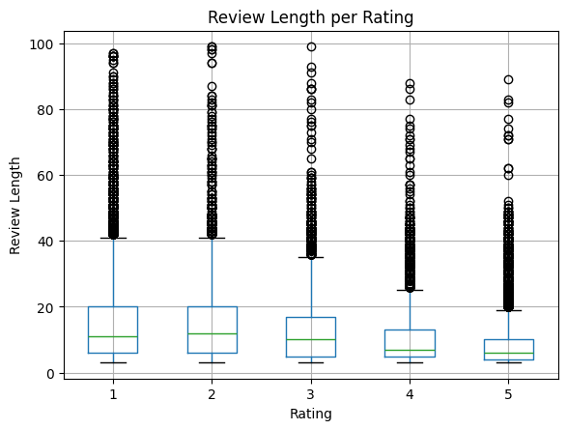

- Lower ratings tend to have longer reviews
Ratings 1 and 2 show higher median review lengths compared to higher ratings, indicating that dissatisfied users generally write more detailed feedback.
- Higher ratings have shorter and more consistent reviews
Ratings 4 and 5 show lower median word counts with tighter interquartile ranges, suggesting that satisfied users give shorter and more uniform reviews.
- Outliers exist across all ratings
Every rating level has several high-length outliers (very long reviews), meaning some users provide detailed explanations regardless of whether the rating is high or low.

Violin plot – Visualize density and distribution of review length

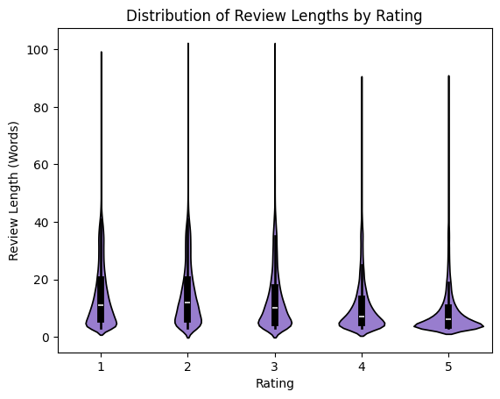

- Review lengths are fairly similar across all ratings (1–5): The violin plots show comparable distributions of word counts for each rating category, suggesting that rating does not strongly influence review length.
- Most reviews are short: Across all ratings, the highest density is concentrated at lower word counts (roughly 3–10 words), indicating that users generally write concise reviews regardless of score.
- Presence of long-review outliers: Every rating category contains a few unusually long reviews, as shown by the extended upper tails, although these are relatively rare compared to shorter reviews.

Display the most common words for each rating class

- Good
- Date
- Great
- People

5. Meet
6. Like
7. use

- Like
- Match
- People
- Message
- Pay
- Good
- use
⭐⭐⭐⭐- Rating 4

- Like
- Good
- People
- Match
- Use
- Date
- great
⭐⭐⭐- Rating 3

⭐⭐⭐⭐⭐- Rating 5

⭐⭐- Rating 2

⭐- Rating1
- Like
- Match
- Pay
- People
- Use
- Profile
- message
- Like
- Match
- Pay
- Use
- Time
- Money
- people

data1.head()

reviewId | content | score | thumbsUpCount | at | word_count | char_count
a0060cfe-9e87-4694-8268-27025b9d9141 | swipe swipe connection | 1 | 0 | 2026-05-23 23:36:38 | 3 | 22
e7bdd002-fc77-4314-a4b2-6060efe53a0d | supposedly like swipe age pay premium price ri... | 1 | 0 | 2026-05-23 23:27:41 | 18 | 122
fdaa6093-a265-4066-9a86-7a6db0915ef4 | scam fake profile use opening format include i... | 1 | 0 | 2026-05-23 22:23:48 | 15 | 96
4521430f-ec5c-4a26-a095-bfeb85cdcc7a | message long upload app freeze constantly | 1 | 0 | 2026-05-23 21:03:55 | 6 | 41
68abfb71-cec5-4ef7-b347-0556ed7121f8 | easy use app | 5 | 0 | 2026-05-23 21:00:40 | 3 | 12

Display 5 reviews per Rating

Rating: 1

1. app update woman use long require reach allow man occasionally message lead woman likely initiative app long special unique
2. bad tinder wait like 20 hour able swipe swipe right maybe 10 people swipe trash app stick home thank covid basically force people pay premium ashamed
3. way include pay premium boost recommend app bumble
4. use day login try reset password appear error try later recognize phone number
5. mandatory pay ridiculous especially people struggle money

Rating: 2

1. good woman creepy message woman man think date 5050 eye 70 try conversation dry date app base look difficult find look past look
2. badly app slow load load time regardless network connection open app right
3. jury bumble agree pay upgrade like paypal account debit time contact bumble await reply reimbursement money
4. notification feature additional cost
5. bad online date site ve respond look special plastic people time feel need spend money meet woman ill strip club chance conversation woman strip club online date site truth hurt

Rating: 3

1. good experience matching meet nice people correspond look problem realize stop match regularly know ploy upgrade customer support help
2. rate app high app actually sound send push notification great interface
3. list farmer possible profession list scientist profession career start personal come guy
4. glad old layout tapping info hard scroll paywall ridiculous 50 like miss match
5. ok app help find match proactively

Rating: 4

1. smooth love interface
2. like lady chooser
3. ok site maybe ugly fun
4. issue connect spotify account reason unable
5. enjoy app pretty expensive basic feature worth fun pay result tho

Rating: 5

1. nice app meet new people relaxing chat guy swipe right
2. good app far
3. problem app fact allow meet wonderful girlfriend worth star
4. good app communication new friend
5. great app real people


Create Imbalanced dataset

To simulate a realistic review distribution and evaluate model performance under class imbalance, an imbalanced dataset was created from the original review dataset. Rather than sampling a fixed proportion from each rating category, a predefined number of reviews was selected from each class to achieve a target distribution. Specifically, 20,000 reviews were randomly sampled from the 1-star category, 13,333 reviews from the 2-star category, 6,667 reviews from the 3-star category, 10,000 reviews from the 4-star category, and 16,667 reviews from the 5-star category. This resulted in a dataset containing 66,667 reviews with a class distribution of 30%, 20%, 10%, 15%, and 25% for the 1-star, 2-star, 3-star, 4-star, and 5-star ratings, respectively.
This distribution intentionally creates unequal class representation, enabling the model to be trained and evaluated under conditions that more closely resemble real-world scenarios where certain rating categories are more prevalent than others. The resulting dataset was randomly shuffled to eliminate any ordering effects before model training and evaluation. Such an imbalanced setup helps assess the robustness of the classification models, identify potential biases toward majority classes, and evaluate their ability to correctly classify underrepresented rating categories.
# Class Distribution after class imbalance

⭐ - 30% - 20000
⭐ ⭐ - 20% - 13333
⭐ ⭐ ⭐ -10% - 6667
⭐ ⭐ ⭐⭐ -15% - 10000
⭐ ⭐ ⭐⭐⭐ -25% - 16667

# Define the required number of reviews per rating
sample_counts = {
1: 20000, # 30%
2: 13333, # 20%
3: 6667, # 10%
4: 10000, # 15%
5: 16667 # 25%
}

# Create imbalanced dataset
imbalanced_data = pd.concat([
data1[data1['score'] == rating].sample(
n=count,
random_state=42
)
for rating, count in sample_counts.items()
])

# Shuffle the dataset
imbalanced_data = imbalanced_data.sample(
frac=1,
random_state=42
).reset_index(drop=True)

# Display class distribution
print("Class Distribution:")
print(imbalanced_data['score'].value_counts().sort_index())

print("\nPercentage Distribution:")
print(
(imbalanced_data['score'].value_counts(normalize=True) * 100)
.sort_index()
.round(2)
)

print("\nTotal Samples:", len(imbalanced_data))

# Output:

Class Distribution:
score
1 20000
2 13333
3 6667
4 10000
5 16667

Percentage Distribution:
score
1 30.0
2 20.0
3 10.0
4 15.0
5 25.0

Total Samples: 66667

Train-Test data splitting

- The dataset is divided into input features (content) and target labels (score) for model training and evaluation.
- The train_test_split() function splits the data into 70% training data and 30% testing data, while stratify=y preserves the original class distribution across both sets.

from sklearn.model_selection import train_test_split
X = balanced_data['content']
y = balanced_data['score']
X_train, X_test, y_train, y_test = train_test_split(
X, y, test_size=0.3, random_state=42, stratify=y )

Vectorizing text - TF-IDF

TF–IDF is a feature extraction technique used in Natural Language Processing (NLP) to convert textual data into numerical representations that can be processed by machine learning algorithms. It assigns weights to words based on their importance within a document and across the entire corpus. This technique represents each review based on the importance of its words, enabling machine learning algorithms to effectively process and classify the textual data. The generated TF–IDF feature matrix served as the input for subsequent model training and evaluation.
The TF–IDF score is calculated using two components:
1. Term Frequency (TF): Measures how frequently a term appears in a document.
$$TF(t,d)=\frac{\text{Number of times term }t\text{ appears in document }d}{\text{Total number of terms in document }d}$$
2. Inverse Document Frequency (IDF): Measures how important a term is by reducing the weight of commonly occurring words across documents.
$$IDF(t)=log⁡\left(\frac{N}{df(t)}\right)$$
where:
- $N$= Total number of documents
- $df(t)$= Number of documents containing term $t$
The final TF–IDF score is obtained by multiplying TF and IDF:
$$TF\text{-}IDF(t,d)=TF(t,d)×IDF(t)$$
A higher TF–IDF value indicates that a word is frequent in a specific document but relatively rare across the dataset, making it more informative for text classification tasks. In this project, TF–IDF vectorization was used to transform review text into numerical feature vectors for sentiment/rating prediction models.

vectorizer = TfidfVectorizer(
max_features = 500, # Keep only the top 500 words in the dataset
ngram_range = (1,2) #This controls how words are grouped
)
# Fit ONLY on training data
x_train_vec = vectorizer.fit_transform(X_train)

# Transform test data using same vectorizer
x_test_vec = vectorizer.transform(X_test)

print(x_train_vec.shape)
print(x_test_vec.shape)

# (46666, 500) – Training set size is 46666
(20001, 500) - Testing set size is 20001
Where:
- 46666/ 20001= number of reviews (samples)
- 500 = number of text features (selected words/ngrams)

